SOFTWARE TESTING PRACTICAL REPORT
Practical 3: Find Element Using ID – Login Automation
Field | Details
Practical | 3
Testing Type | Automated Functional / UI Testing
Automation Tool | Selenium WebDriver
Programming Language | Python
Browser | Google Chrome
Application Under Test | The Internet – Login Page
Test Scenario | Locate username and password fields using By.ID, enter valid credentials, locate the login button using By.CSS_SELECTOR, click it, and verify the resulting URL.
Expected Result | Successful login should redirect the browser to https://the-internet.herokuapp.com/secure.
1. Test Objective
To demonstrate how Selenium WebDriver identifies HTML elements using the ID locator and performs a complete login workflow. The test also demonstrates CSS Selector usage for the login button and verification using the current URL.
2. Test Case
Parameter | Test Details
Test Case ID | TC-03
Test Case | Login automation using ID locator
Precondition | Python, Selenium WebDriver, Google Chrome, and a compatible Chrome WebDriver are installed and configured.
Test Data | Username: tomsmith  Password: SuperSecretPassword!
Locators Used | By.ID – "username", "password"  By.CSS_SELECTOR – "button[type='submit']"
Test Steps | 1. Launch Chrome  2. Open the login page  3. Maximize the browser  4. Wait for the page to load  5. Locate username field using ID  6. Enter username  7. Locate password field using ID  8. Enter password  9. Locate login button using CSS Selector  10. Click Login  11. Wait for navigation  12. Print current URL  13. Close browser
Expected Result | User should be logged in successfully and redirected to the Secure Area page.
3. Automation Source Code
# 3. Find Element Using ID
from selenium import webdriver
from selenium.webdriver.common.by import By
import time
driver = webdriver.Chrome()
driver.get("https://the-internet.herokuapp.com/login")
driver.maximize_window()
time.sleep(2)
# Find username field using ID
username = driver.find_element(By.ID, "username")
# Enter username
username.send_keys("tomsmith")
# Find password field
password = driver.find_element(By.ID, "password")
# Enter password
password.send_keys("SuperSecretPassword!")
# Find login button
login_button = driver.find_element(
By.CSS_SELECTOR,
"button[type='submit']"
)
# Click login
login_button.click()
time.sleep(2)
print("Current URL:", driver.current_url)
driver.quit()
4. Test Execution Result
The supplied screenshots provide execution evidence for the login automation. The first screenshot shows the automated Chrome session on the login page. The second screenshot shows the login form with the username and password fields and Login button. The third screenshot shows successful navigation to the Secure Area with the confirmation message “You logged into a secure area!” and the URL ending in /secure.
Execution Check | Status
Chrome Browser Launch | PASS
Login Page Navigation | PASS
Browser Maximization | PASS
Username Located Using By.ID | PASS
Password Located Using By.ID | PASS
Credentials Entered | PASS
Login Button Located Using CSS Selector | PASS
Login Button Clicked | PASS
Successful Redirect to /secure | PASS
Overall Test Status | PASS
5. Test Evidence / Screenshots
The following screenshots were supplied as evidence of the Selenium test execution and successful login.
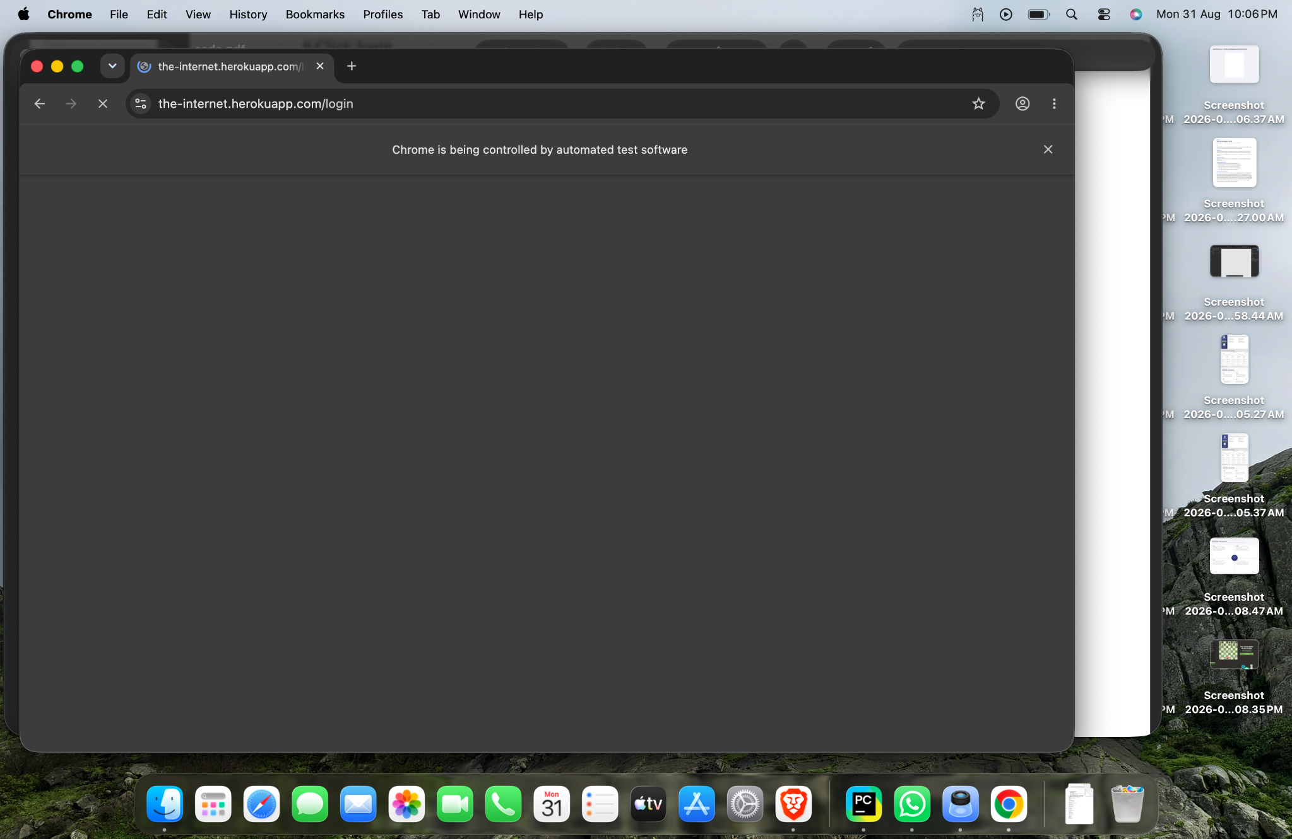
Figure 1: Selenium login automation evidence

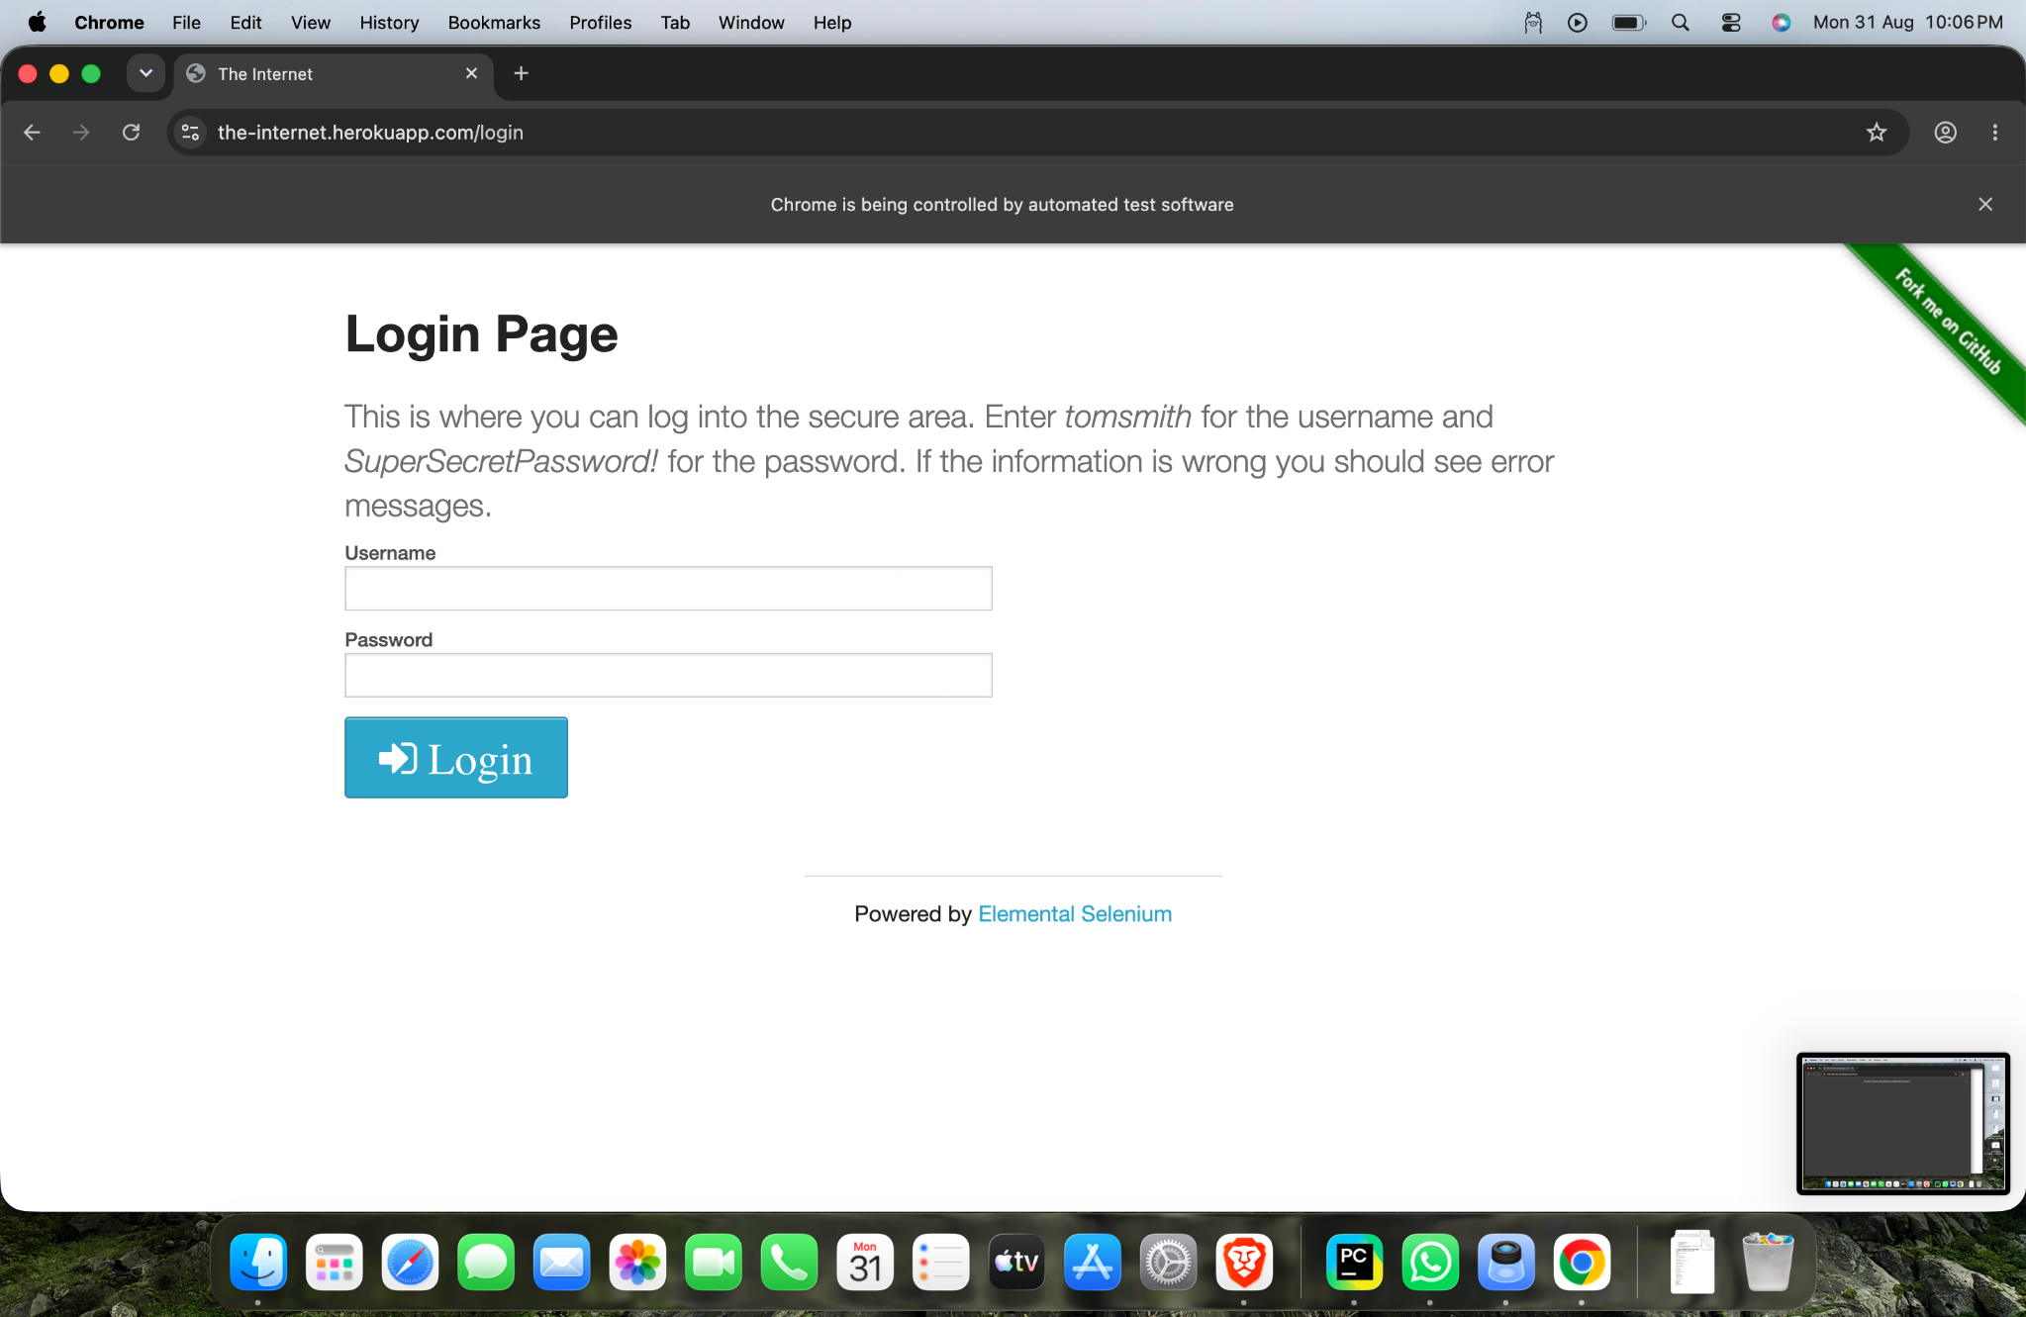
Figure 2: Selenium login automation evidence

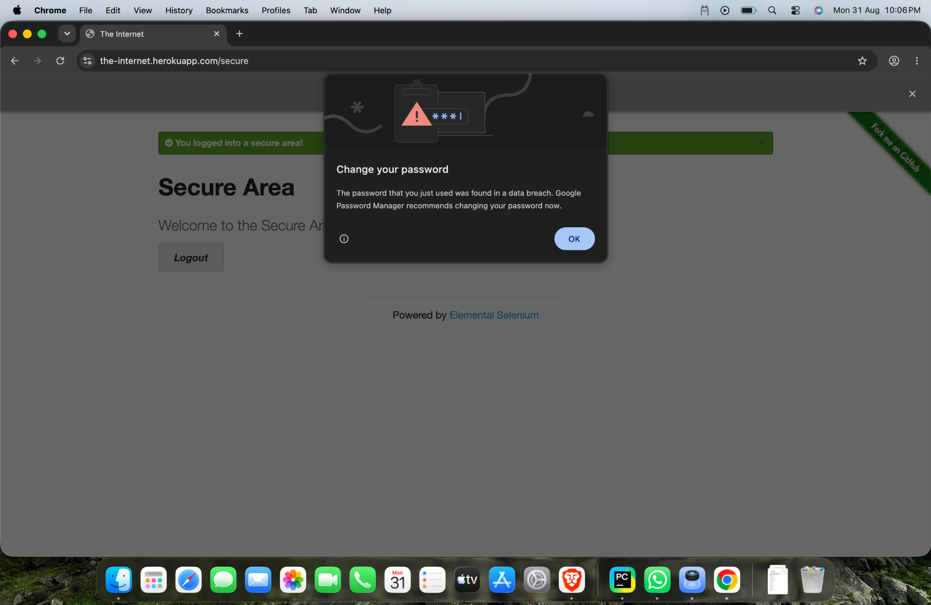
Figure 3: Selenium login automation evidence

6. Main Selenium Concepts
Concept | Purpose
By.ID | Locates an HTML element using its unique ID attribute.
By.CSS_SELECTOR | Locates an element using a CSS selector expression.
send_keys() | Enters text into an input field.
click() | Performs a click action on a web element.
current_url | Returns the URL of the current browser page.
maximize_window() | Maximizes the browser window.
quit() | Closes the browser and ends the WebDriver session.
7. Locator Details
The username field is located with By.ID, "username", and the password field with By.ID, "password". The login button is located using the CSS selector "button[type='submit']". This practical demonstrates that Selenium can combine different locator strategies within the same test case.
8. Expected vs Actual Result
Item | Result
Expected URL | https://the-internet.herokuapp.com/secure
Observed URL | https://the-internet.herokuapp.com/secure
Login Confirmation | “You logged into a secure area!”
Result | PASS
9. Tester Observation
The login workflow executed as expected. The screenshots show Selenium controlling Chrome and the application displaying the successful-login confirmation. The test demonstrates a positive functional test case using valid credentials and verifies navigation to the secure area.
10. Conclusion
This practical successfully demonstrates Selenium WebDriver element identification using By.ID and By.CSS_SELECTOR. It covers browser initialization, navigation, element location, text entry, button interaction, URL verification, and browser termination. The observed result matches the expected result, therefore the test case is considered PASS.
11. Tester Assessment
Test Case: Login automation
Primary Locator: By.ID
Secondary Locator: By.CSS_SELECTOR
Test Data: Valid username and password
Observed Result: Successful login and redirect to /secure
Overall Status: PASS
Testing Skill Demonstrated: Element identification and functional UI automation using Selenium WebDriver.

